Calibration Summary: Revelstoke

Basin Info
Location | 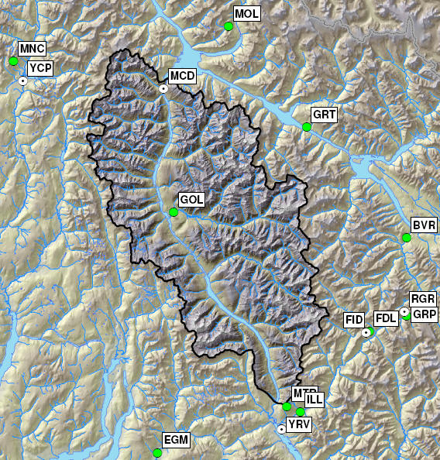
Drainage area | 5253.4 km²
Elevation | Min | 506 m |  |  | Max | 3193 m
Glaciated Area | 235.8 km² (4.5%)
Hypsographic Curve | 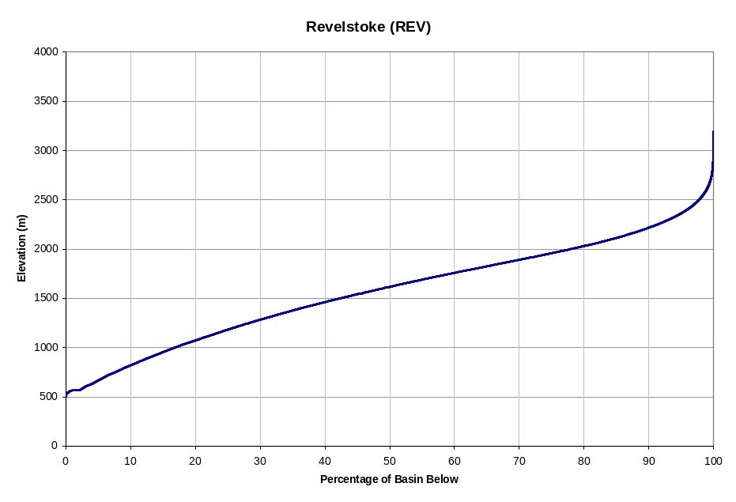
Avg. Annual Precipitation ¹⁾ | 1585 mm (PRISM: 1554 mm) |  |  | Avg. Annual Snowfall ¹⁾ |  |  |  | 1106 mm (70% P)
Avg. Annual Runoff | 1357 mm (226 m³/s ; 86% P) |  |  | Avg. Glaciermelt Runoff ¹⁾ |  |  |  | 106 mm (7.8% Q)
Avg. Annual Hydrograph / Hyetograph | 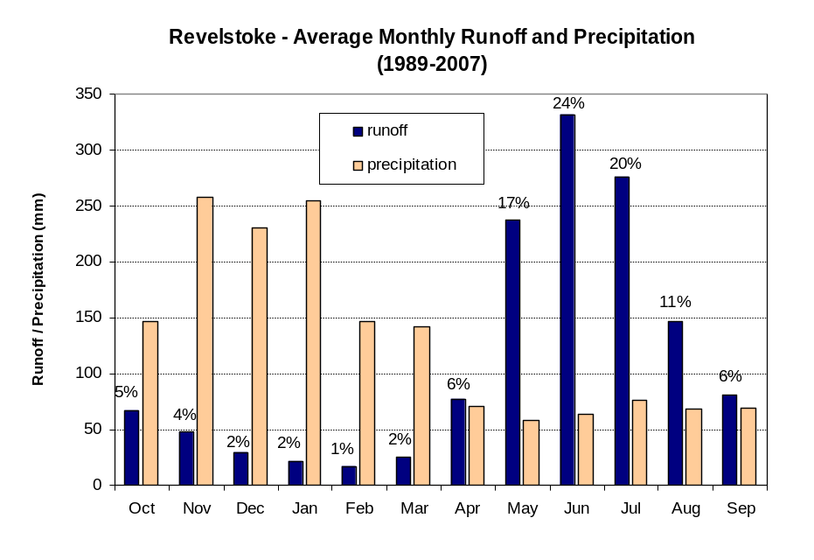
Normal Runoff (1971-2000) | Month |  | Inflow (cms) |  |  |  | Inflow (10⁶ m³)
Normal Runoff (1971-2000) | Jan |  | 49.8 |  |  |  | 133.5
Normal Runoff (1971-2000) | Feb |  | 50.5 |  |  |  | 123.3
Normal Runoff (1971-2000) | Mar |  | 59.0 |  |  |  | 158.0
Normal Runoff (1971-2000) | Apr |  | 152.4 |  |  |  | 395.0
Normal Runoff (1971-2000) | May |  | 455.4 |  |  |  | 1219.8
Normal Runoff (1971-2000) | Jun |  | 690.1 |  |  |  | 1788.7
Normal Runoff (1971-2000) | Jul |  | 552.9 |  |  |  | 1481.0
Normal Runoff (1971-2000) | Aug |  | 351.4 |  |  |  | 941.2
Normal Runoff (1971-2000) | Sep |  | 207.2 |  |  |  | 537.0
Normal Runoff (1971-2000) | Oct |  | 138.8 |  |  |  | 371.8
Normal Runoff (1971-2000) | Nov |  | 106.9 |  |  |  | 277.0
Normal Runoff (1971-2000) | Dec |  | 74.5 |  |  |  | 199.5
Runoff Regime | Nival-glacial
Main Tributaries | Goldstream River below Old Camp Creek (GOL)
Best Reference Stream (R²) | Goldstream River below Old Camp Creek (WSC 08ND012; R² = 0.97)

Notes 1) Estimated from UBC watershed model

Calibration Info
Calibration Period | 1989-2007
Verification Period | 1984-1989
# of Elevation Bands | 10
Temperature Data  - Band assignment  - Filename  - Composition  - Station 1  - Station 2  - TS ID | [All bands]  REVComp.ADC  0.5 MCD + 0.5 RGR  Mica Dam (MCD; 579 m)  Glacier National Park – Roger’s Pass (RGR; 1323 m)  100000.1/102.00/314 (312)
Precipitation Data  - Band assignment  - Filename  - Composition  - Station 1  - Station 2  - TS ID | [All bands]  REVComp.ADC  0.57 MCD + 0.43 RGR  Mica Dam (MCD; 579 m)  Glacier National Park – Roger’s Pass (RGR; 1323 m)  100000.1/110.00/315
Flow Data  - TS ID | 100000.1/110.00/315
Parameters  - Filename  - Date | REV.wat  Jan 20, 2010
Time Constants  - Fast runoff -rain  - Fast runoff - snowmelt  - Fast runoff - glacier  - Interflow - rain  - Interflow - snowmelt  - Upper groundwater  - Deep groundwater | 0.62 days  0.79 days  0.93 days  3.7 days  11.6 days  40.3 days  161 days
Folder Name | J:\PS\pso\Hydrology\UBCWM calibration 2008\results\FINAL\REV
Modeler | S. Weston

Best-of-ensemble Parameter Set Performance Statistics
Daily  Nash-Sutcliff | Monthly  % volume error |  |  |  |  |  |  |  |  |  |  |  | Yearly  % volume error
 | Jan | Feb | Mar | Apr | May | Jun | Jul | Aug | Sep | Oct | Nov | Dec
2001 calibration, total period (Oct 1 1984 to Sep 30 1994)
0.91 | 20.9 | 45.1 | 0.3 | -23.9 | -1.0 | 2.8 | -6.4 | 6.8 | 3.5 | 4.3 | -3.8 | 22.7 | 0.6
Absynthe, total period (Oct 1 1984 to Sep 30 2007)
0.93 | 2.8 | 1.7 | 5.6 | -6.2 | -1.9 | 3.1 | -3.6 | 1.6 | 5.8 | 5.8 | -9.2 | -4.6 | -0.5
Absynthe, calibration period (Oct 1 1989 to Sep 30 2007)
0.93 | 3.3 | 6.7 | 5.9 | -6.6 | -2.1 | 2.6 | -4.2 | 3.3 | 7.0 | 7.5 | -9.5 | -5.4 | -0.6
Absynthe, validation period (Oct 1 1984 to Sep 30 1989)
0.92 | 8.2 | -12.1 | 7.7 | -3.8 | -0.9 | 5.1 | -0.8 | -4.4 | 1.4 | 4.4 | -1.9 | 6.3 | 0.7

Comments

Additional Documentation
- J:\PS\pso\Hydrology\UBCWM calibration 2008\results\ALU \Alouette2008RecalibrationResults_V2.doc
- J:\PS\pso\Hydrology\UBCWM calibration 2008\documents\UBCWM Recalibration Roadmap\ UBCWM_RecalibrationRoadmap_2ndDRAFT_v1.doc
- J:\PS\pso\Hydrology\UBCWM calibration 2008\documents\UBCWM Recalibration Roadmap\ UBCWM_RecalibrationRoadmap_JULY2008-ADDENDUM_v7.doc
- Scott – DMC analysis
- Scott – GIS analysis

Calibration reviewed by: F. Weber
Date: May 19, 2009

